EMPLOYEE MANAGEMENT SYSTEM

01 ERD Design & Mapping

Task 1: Draw the Full ERD
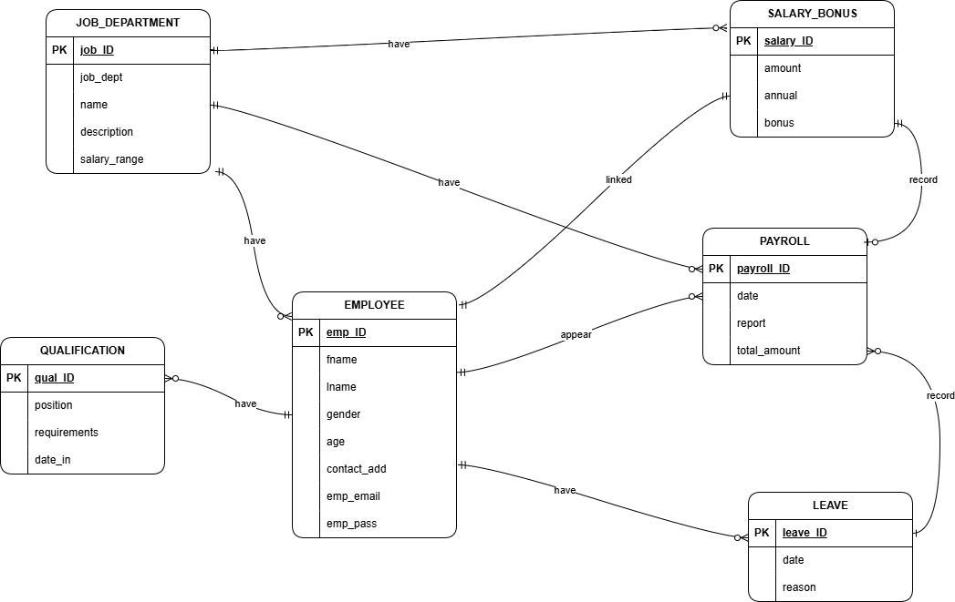

Task 2: Map the ERD to a Relational Schema

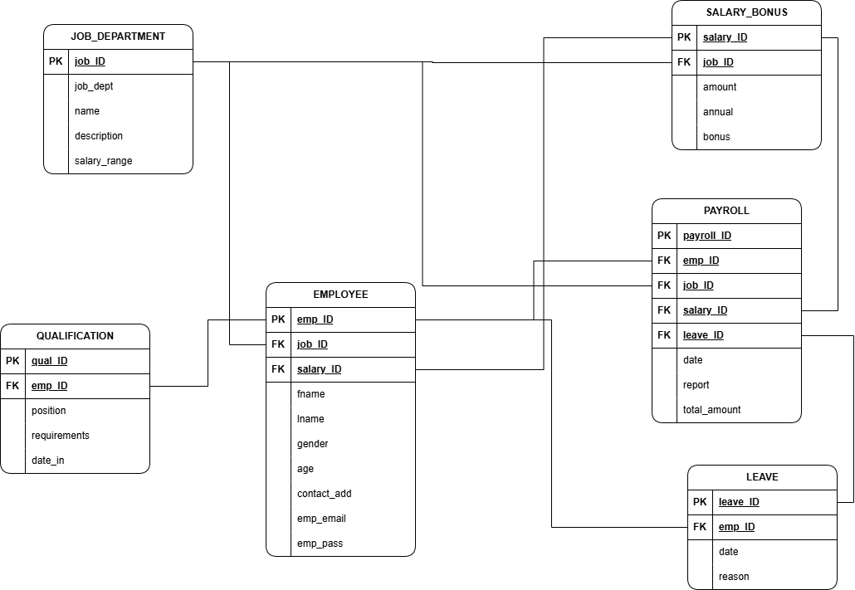
EMS Schema
JOB_DEPARTMENT ( job_ID, job_dept, name, description, salary_range )
SALARY_BONUS ( salary_ID, amount, annual, bonus, job_ID )
EMPLOYEE ( emp_ID, fname, lname, gender, age, contact_add, emp_email, emp_pass, job_ID, salary_ID )
QUALIFICATION ( qual_ID, position, requirements, date_in, emp_ID )
LEAVE ( leave_ID, date, reason, emp_ID )
PAYROLL ( payroll_ID, date, report, total_amount, emp_ID, job_ID, salary_ID, leave_ID )

02 Normalization

Task 1: First Normal Form (1NF) Analysis
Rule: every cell must hold exactly one atomic value. No lists, no repeating groups, no multivalued columns.
Table | 1NF Rule Applied
JOB_DEPARTMENT | job_dept, name, description, salary_range — each attribute holds one atomic value. No column stores a list.
SALARY_BONUS | amount, annual, bonus — each is a single atomic numeric value.
EMPLOYEE | fname, lname, gender, age, contact_add, emp_email, emp_pass — every attribute is atomic. No column stores multiple emails, phone numbers, or values.
QUALIFICATION | position, requirements, date_in — atomic. An employee with multiple qualifications is represented as multiple ROWS (via the emp_ID FK), not as multiple values packed into one cell.
LEAVE | date, reason — atomic. Multiple leave records per employee = multiple rows, not a list in one cell.
PAYROLL | date, report, total_amount — atomic. Each payroll entry is one row with single-valued fields.

Task 2: Second Normal Form (2NF) Analysis

Rule: a table must already be in 1NF, and every non-key attribute must depend on the WHOLE primary key — not just part of it. This rule only applies when a table has a composite (multi-column) primary key. If a table's primary key is a single column, it automatically satisfies 2NF once it is in 1NF.

Table | Primary Key | Composite PK? | 2NF Result
JOB_DEPARTMENT | job_ID | No | Satisfies 2NF
SALARY_BONUS | salary_ID | No | Satisfies 2NF
EMPLOYEE | emp_ID | No | Satisfies 2NF
QUALIFICATION | qual_ID | No | Satisfies 2NF
LEAVE | leave_ID | No | Satisfies 2NF
PAYROLL | payroll_ID | No | Satisfies 2NF

03 SQL DML — INSERT / UPDATE / DELETE / SELECT

